Challenging the Mechanism for the Implicit Association Test

Kyle J. LaFollette¹*, Doroteja Rubez¹, Heath A. Demaree¹, and Amit Goldenberg^{2,3,4}
¹ Case Western Reserve University, Department of Psychological Sciences, Cleveland, USA
² Harvard University, Harvard Business School, Boston, USA
³ Harvard University, Department of Psychology, Cambridge, USA
⁴ Harvard University, Digital, Data and Design Institute

* Corresponding author: Kyle J. LaFollette (kjl113@case.edu).

Abstract
Implicit biases are stereotypes and attitudes that impact our decisions and actions, playing an important role in discrimination and societal inequities. The most widely used tool for measuring implicit bias is the Implicit Association Test (IAT), which assesses response time in sorting stimuli into labeled categories. Most interpretations of the IAT assume that response time is driven by the activation of conflicting associative memories, or decision ease. In the current project we wish to challange this assumption by testing another process that may impact IAT results, response caution, which is people’s tendency to sacrifice speed for accuracy. We use Racing Diffusion Models to differentiate the effects of decision ease and response caution on IAT results across 39 topics. Exploratory analyses suggest that response caution is a stronger predictor of both IAT scores and explicit preferences relative to decision ease. Our findings have important implications for IAT assessment and interventions.

Keywords: Implicit association test, racing diffusion model, response caution, decision ease

Implicit biases are attitudes or stereotypes that affect our understanding, actions, and decisions of the world, often without our knowledge¹. Social scientists typically define implicitness as either being a property of unconscious mental representations or of measures that are designed to test constructs indirectly, avoiding the filter of self-report^{2–5}. These features of implicit bias make its measurement very challenging. To overcome this challenge, social scientists are tasked with developing measures that capture implicit behavior and that are less susceptible to external pressures and social desirability than self-report^{1,6–9}. Developing these measures is especially difficult, because people seem to be able to fake their performance even when measures are supposed to be implicit^{10–13}.
Many different measures have attempted to capture implicit bias, but the most commonly used one is the Implicit Association Test (IAT)^{3,4}. The IAT involves presenting participants with target concepts (e.g., images of Black or White faces) and attribute concepts (e.g., good or bad words), and asking participants to sort these stimuli into their respective categories (see Figure 1). Target and attribute categories are later combined such that they are either compatible with biased beliefs (i.e., “White/good”, “Black/bad”) or incompatible (i.e., “White/bad”, “Black/good”). In the incompatible block of the race IAT, as one prominent example, images of Black faces and positive or good words (e.g. beautiful, pleasant) are mapped onto one response key, while images of White faces and negative or bad words (e.g. ugly, unpleasant) are mapped onto another key. The compatible block has the opposite configuration (i.e., “White/good”, “Black/bad”). People tend to respond more slowly on bias-incompatible blocks than the bias-compatible blocks, a behavior termed the IAT effect. To quantify this effect, many researchers use D-scores, which are the difference in response time between compatible and incompatible blocks divided by their pooled standard deviation. At least six different D-score algorithms are proposed, each differing in their treatment of short response times and error trials^{14,15}.
Given the assumed ability of the IAT to bypass external pressures and social desirability^{3–5}, it has been widely used to detect and evaluate bias in healthcare^{16,17}, law enforcement¹⁸, and education^{19,20}. Although the IAT has been widely adopted, it has also been heavily criticized. One critique of the IAT is its limited construct validity and general inability to predict real-world behaviors^{5,21,22}. Different versions of the IAT may have different construct validities: Whereas some authors find that IATs measuring political biases are valid²³, others find that IATs measuring implicit self-esteem are not²⁴. Some authors suggest that the IAT may be no better, or even worse than explicit measures at gauging bias^{25,26}. A second critique of the IAT and D-scores is that responses can be falsified, which can partially explain variability in D-scores^{10–13}. This suggests that the same subjective filters that influence a person’s explicit reporting of preferences may also influence their IAT performance. These criticisms suggest that further understanding of the underlying mechanisms driving variability in D-scores may help explain the IAT’s low construct validity, and the ability to falsify one’s performance.
The original and most common interpretation of the IAT effect is that people process the compatible blocks more quickly due to complementary associative memory content⁴, a mechanism reflecting decision ease. Incompatible blocks are responded to more slowly due to the contents of associative memory conflicting with task instructions, reflecting lesser decision ease. However, some researchers have suggested that the reason participants slow down on incompatible blocks may not entirely be due to their decision ease, but also because they become more cautious of making an error on incompatible trials⁵. Response caution reflects people slowing down on incompatible trials in order to avoid making mistakes. Response caution is caused either because the incompatible trials are more difficult and require slowing down²⁷, or because they impose pressure to fake performance^{28,29}.
Notice the distinction between decision ease and response caution: Whereas decision ease is driven by existing associative memory between concepts and attributes, response caution is driven by subjective control to improve accuracy in performance. Previous studies have mostly neglected the question of whether these mechanisms are independently responsible for variance in IAT performance or whether they serve as a link between IAT performance and explicit preferences. One exception is work by Klauer and colleagues³⁰, who tested the association between IAT performance and explicit preferences in the context of political attitudes, finding that preferences were only explained by decision ease. This work, however, was limited in power and topic. A comprehensive analysis of whether decision ease and response caution predict IAT effects, and whether either of those predict explicit preference is needed across a wide range of IAT topics to further understand the notion of implicit bias.
In response to longstanding issues with the IAT, a growing number of researchers advocate for transitioning away from summary statistics like D-scores and instead using more sophisticated computational approaches^{31–33}. One such approach is the Racing Diffusion Model (RDM)³⁴, a mathematical model that assumes decisions are made by accumulating bits of evidence for competing choices over time until some evidence threshold is met for either of those choices (see Figure 2). The rates of evidence accumulation are reflected in the RDM’s “drift rate” parameter, which can be thought of as decision ease. This ease is driven by the activation of associative memory content^{35,36}, such as the biased association between White persons and good. Conversely, the RDM’s “evidence threshold” parameter reflects response caution which is responsible for speed-accuracy tradeoffs. Since the earliest explorations of the IAT, diffusion models have been used for examining IAT performance^{29,30,37,38}. However, these attempts mainly focused on examining the association between decision ease and the D-score, without paying enough attention to response caution as a separate predictor of the D-score. A third, less relevant property captured by the RDM is non-decision time, or the proportion of response time unrelated to processes of decision-making, such as stimulus encoding or pre-motor planning. Unlike decision ease or response caution, prior work suggests that non-decision time is unrelated to neither method-specific nor construct-specific variance in IAT performance³⁰. Nevertheless, accounting for variability in non-decision time can contribute to more precise estimates of decision ease and response caution.
The distinction between decision ease and response caution raises questions about the degree of conscious control people may have over either of these mechanisms. Many leading experts on decision diffusion modeling describe decision ease as reflecting abilities not under subjective control, whereas response caution is strategic and varies with participants’ relative emphasis on speed versus accuracy^{39–42}. In support of this description, researchers find that only decision ease adapts with information contained by masked or suppressed stimuli outside of conscious awareness^{43,44}. Response caution on the other hand, seems to be susceptible to instructional emphases on speed or accuracy^{45–49} and has been linked to a network of brain regions associated with voluntary action and effortful control over behavior^{50–53}. Taken together, these findings have led researchers to argue that changes in response caution are at least partially under conscious control.
In the present study, we will use the RDM to distinguish between decision ease and response caution in predicting both D-score and explicit preferences. First, we aim to uncover the degree to which IAT effects are driven by decision ease, response caution, and non-decision time. We hypothesize that decision ease, response caution, and non-decision time will on average significantly differ between compatible and incompatible IAT blocks (Hypothesis 1; Design Table). Second, we hypothesize that response caution will have the greatest effect on D-score, explaining variance in D-score above and beyond that explained by both decision ease and non-decision time (Hypothesis 2). In addition to the traditional D-Score, we will test this hypothesis on five alternative D-score algorithms^{14,15}. Finally, we aim to uncover which of those mechanisms (decision ease, response caution, non-decision time) are more associated with explicit preferences. Based on the majority of previous research suggesting both response caution and explicit preferences to be susceptible to subjective control, and supported by our pilot analyses with an exploratory dataset, we hypothesize that explicit preferences will be predicted solely by response caution and not decision ease nor non-decision time (Hypothesis 3). We will test these hypotheses using a large dataset of ~109,417 unique IAT sessions made up of 39 different IATs.

Methods

Ethics Information
Our research complies with all ethical regulations. Our analyses will use data collected from the Ideology 2.0 Study⁵⁴ on Project Implicit from December 2007 to June 2012. Data collection was approved by the University of Virginia’s Institutional Review Board (IRB) for Social and Behavioral Sciences and informed consent was obtained from all participants. The Case Western Reserve University IRB determined that further IRB approval was not required to conduct secondary analyses on these data.

Pilot Data
We conducted exploratory analyses on a subsample of the data for proof-of-concept, separate from a larger held-out confirmatory sample. These analyses are the bases of our expected effect sizes and confirmatory hypotheses. Of the 39 IATs we analyzed, each included at least 746 participants (mean=818.589, SD=30.714). We fit both trial-level choice and response time data using the RDM for each IAT separately (see Analysis Plan for details). Decision ease, response caution, and non-decision time were defined as the difference in RDM average rate of evidence accumulation, evidence threshold, and non-decision time, respectively, between the incompatible and compatible blocks. Bayesian equivalence tests revealed strong evidence for a large effect of decision ease between incompatible and compatible blocks (mean difference=-5.738, 95%HDI=[-8.471, -3.008], BF>1000), with 30 of the 39 IATs having negative effects (Figure 3), suggesting relatively less ease in the incompatible block. We also observed strong evidence for a large effect of response caution between blocks (mean difference=39.479, 95%HDI=[36.803, 42.252], BF>1000), with 37 of the 39 IATs having positive effects, suggesting relatively greater response caution in the incompatible block. Finally, we observed strong evidence for a large effect of non-decision time between blocks (mean difference=-31.538, 95%HDI=[-34.305, -28.894], BF>1000), with 36 of the 39 IATs having negative effects suggesting relatively less non-decision time in the incompatible block. See SI for individualized effects from each IAT.
Although decision ease, response caution, and non-decision time were all significant predictors of D-Score (Absolute mean β_{ease}=0.353, 95%CI=[0.236, 0.470]; Absolute mean β_{caution}=0.965, 95%CI=[0.827, 1.104]; Absolute mean β_{ndt}=0.470, 95%CI=[0.333, 0.607]), the absolute effect of response caution was greater on average than that of both decision ease and non-decision time (Figure 4). We observed this for each of the 6 D-score algorithms (Figure 5). Hierarchical regression models predicting D-score revealed that although a model including both decision ease and non-decision time accounted for a significant proportion of variance in individual D-scores (mean R²=0.633, 95%CI=[0.569, 0.696]), including response caution as a predictor explained greater variance above and beyond decision ease and non-decision time (mean R²=0.784, 95%CI=[0.742, 0.825]). See SI for individualized effects from each IAT.
After establishing associations with the D-score, we next examined the associations between the RDM mechanisms and explicit preferences. We found that explicit preferences were predicted by neither decision ease, response caution, nor non-decision time (mean β_{ease}=-0.045, 95%CI=[-0.296, 0.197]; mean β_{caution}=0.265, 95%CI=[-0.021, 0.551]; mean β_{ndt}=0.119, 95%CI=[-0.162, 0.401]; Figure 6) on average across IATs. However, at an individual level, we found response caution did have a substantial effect on explicit preference for 20 of the 39 IATs, whereas decision ease and non-decision time had effects on explicit preference for only 3 of the 39 IATs each. Together with our hierarchical regression findings, this suggests that IAT D-scores are weak measures of implicit bias as it has been commonly defined. Response caution is largely responsible for IAT D-score and its association with explicit preference. Should our confirmatory analyses support this, we encourage IAT researchers to remember the literature linking response caution and conscious control when considering D-scores. As an alternative to D-scores, we suggest that researchers use diffusion modeling to disentangle response caution from other mechanisms which they may have a greater interest in measuring, such as decision ease.

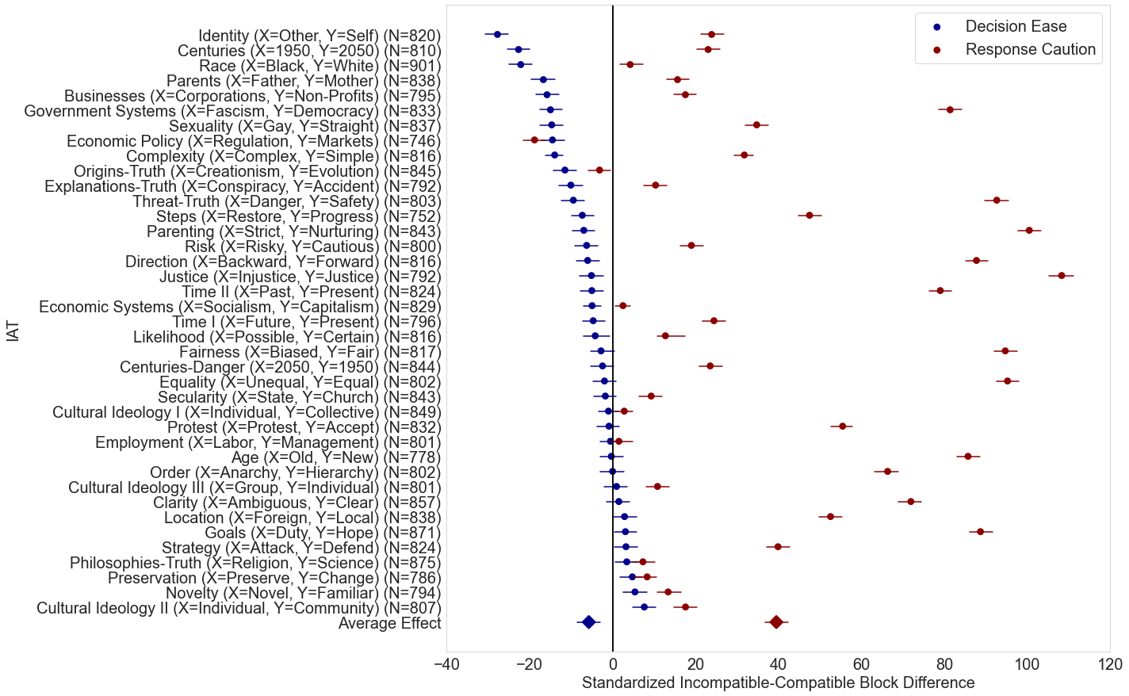
Figure 3. Racing Diffusion Model Parameter Effects. Standardized mean differences between the posterior predictive densities the bias-incompatible and -compatible blocks of each IAT (N=31,925), for decision ease (i.e., average drift rate; blue), and response caution (i.e., evidence threshold; red). Diamonds are the average difference across IAT topics. Error bars are 95% highest density intervals.
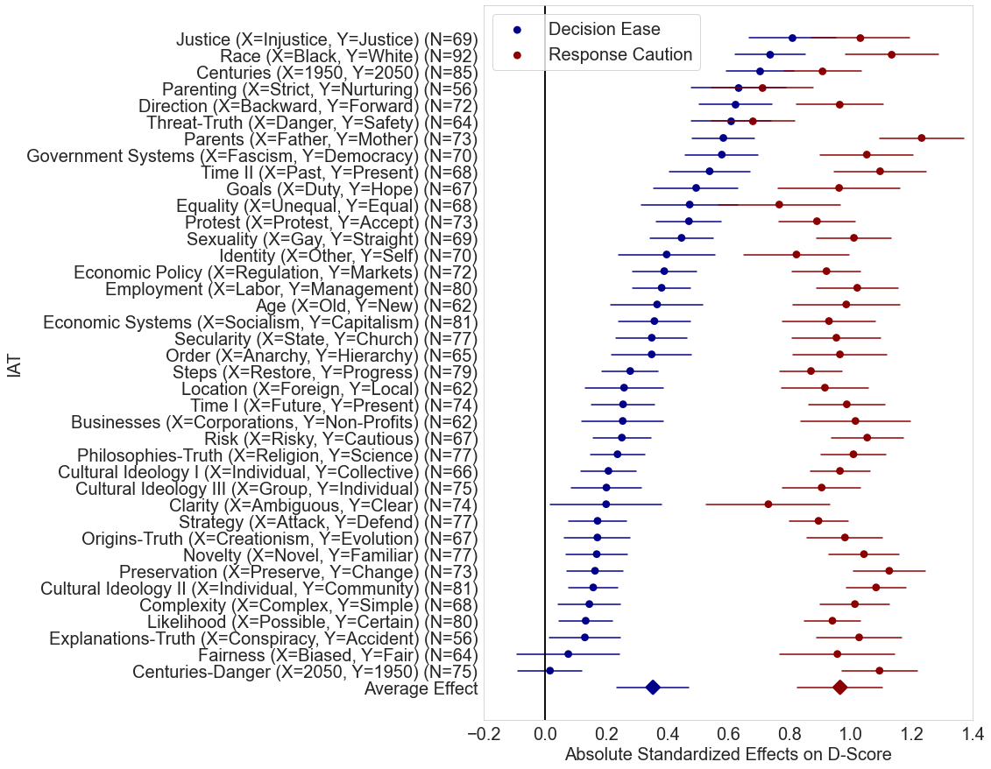
Figure 4. Effects of Decision Ease and Response Caution on D-Score. Absolute standardized effects of decision ease and response caution on D-Score (N=2,787). Dots represent absolute standardized beta coefficients identified from regression models of D-score including fixed effects of decision ease, response caution, and non-decision time (not shown). Diamonds are the average effect across IAT topics. Error bars are 95% confidence intervals.
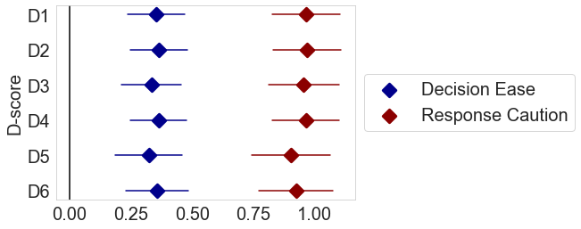
Figure 5. Effects of Decision Ease and Response Caution on each of the 6 D-Score algorithms. Average absolute standardized effects of decision ease and response caution on each of the 6 D-Score algorithms (N=2,787). Diamonds are the average standardized beta coefficients identified from regression models of D-score including fixed effects of decision ease, response caution, and non-decision time (not shown). Error bars are 95% confidence interval.
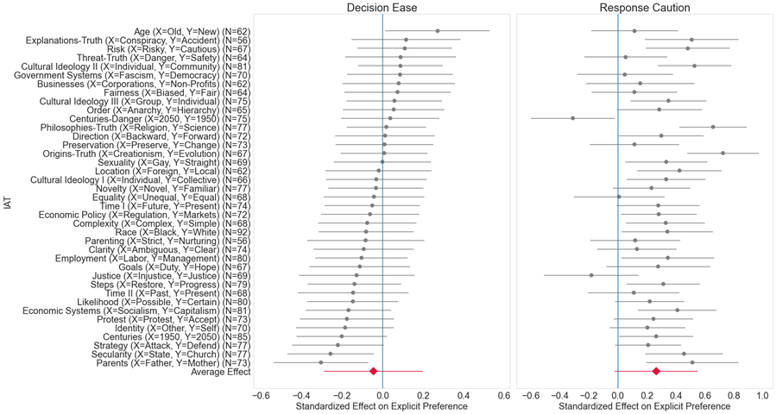
Figure 6. Effects of Decision Ease and Response Caution on Explicit Preference. Standardized effects of decision ease (left) and response caution (right) on explicit preference (N=2,787). Dots represent standardized beta coefficients identified from regression models of explicit preference including fixed effects of decision ease, response caution, and non-decision time (not shown). Red diamonds are the average effects across IAT topics. Error bars are 95% confidence intervals.
Design
Participants were randomly and blindly assigned to one of two study designs: Design A or Design B. Participants in Design A completed one standard or IAT measure of evaluation (Good or Bad), stereotyping identification, or validation (True or False). Participants in Design B were randomly assigned to and completed two IATs. The topic of each IAT was randomly selected from a pool of 39 topics (see Supplemental Materials). Participants also completed explicit preference thermometers and individual difference scales and items following the IAT(s). About 50% of participants who were given any one of the 39 IAT topics also have explicit preference data for that topic. For the proposed confirmatory analysis, we will limit our variables of interest to (1) IAT performance (choices and response times) and (2) explicit preference for the concepts targeted by the IAT. Likewise, only these two variables are considered in our pilot analysis. All other explicit measures and individual difference scales/items will be restricted to exploratory analyses. See below for descriptions of the IAT and explicit measures.

Implicit Association Tests. Standard IATs were composed of four blocks, the first two of which were 20-trial single categorization practice blocks specific to either the target concept (e.g., Black or White) or the attribute for association (e.g., Good or Bad). Labels for these concepts/attributes were presented at the top-left and top-right of the participant’s computer screen whereas the stimuli targeted for classification were presented in the screen’s center. Participants were instructed to use the “E” and “I” keys on their keyboard to classify stimuli with the top-left and top-right labels, respectively. After these practice blocks, participants then completed a 60-trial mixed categorization block where concept and attribute labels were combined (e.g., Black/Bad or White/Good). Another 40-trial target concept categorization block was then administered, followed by a 60-trial mixed categorization block with label combinations inverted from the previous mixed block (e.g., White/Bad or Black/Good). See Figure 5 for standard IAT schematics. Task instructions and stimuli particular to each of the 39 possible IATs are available at: https://osf.io/2483h/. Choices and response times were recorded for each trial. On error trials, the original reaction time was not recorded. Instead, the task persisted until the choice was corrected and only the final reaction time for the correct choice was recorded. As a result, we cannot provide reaction time analysis for any error trials using the RDM. An average 145,985.026 trials (SD=6,748.927) of (only) correct responses will be included from each of the 39 IATs for analysis, with an average 181.454 trials (SD=2.469) per participant after exclusions. See “Analysis Plan: Pre-Processing – Exclusions” for more information on exclusion criteria.

Explicit Preference Thermometers. Following the IAT(s), participants were given a 1-item relative preference (or liking) thermometer measure. The topic of this measure was matched to that of the topic of the IAT performed in Design A (1 IAT test), and at random to one of the IAT topics performed in Design B (two sequential IAT tests). Explicit preference was determined either as the relative preference for one target concept over another (e.g., Black over White on a scale from 1 to 7, with 1 being strong preference for Black over White and 7 strong being preference for White over Black), or the likeability of one specific target (e.g., White on a scale from 1 to 7, with 1 being strong unlikability of White, and 7 being strong likability of White). Each participant was given either the relative preference measure or the likability measure.




Black
White
+
Black
White
Black
White
+
Black
White
Bad
Good
+
Bad
Good
Bad
Good
+
Bad
Good
Joyful
Despise
Black
Bad
White
Good
+
Black
Bad
White
Good
Black
Bad
White
Good
+
Black
Bad
White
Good
Joyful
Black
Good
White
Bad
+
Black
Good
White
Bad
Black
Good
White
Bad
+
Black
Good
White
Bad
Joyful
A
C
B
D
Figure 1. Standard Implicit Association Test Schematics. Participants classified centrally-presented stimuli into categories presented in the top-left and -right of their monitor. (A) Concept-only blocks had participants classify concept-specific stimuli (e.g., Black person, White person, Gay person, Straight person). (B) Attribute-only blocks had participants classify words conveying an attribute (e.g., good, bad, true, false). Mixed blocks either had participants classify concept-specific stimuli and words into mixed categories that were either compatible (C) or incompatible (D) with biased beliefs.
Sampling Plan
Participants. We plan to test our hypotheses on a confirmatory held-out subsample of the Ideology 2.0 dataset. Within this dataset, we will analyze data from ~109,417 unique sessions, spread across 39 IAT topics. On average, 2,735 (SD=95.4) participants completed each IAT, 1,809 (SD=226.04) of whom also completed an explicit preference measure for that IAT’s topic. See Table 1 for anticipated sample size by IAT topic. This held-out sample is masked at the time of submitting the Stage 1 Registered Report.

Table 1. Anticipated Sample Size by IAT Topic

IAT Topic | Sample with IAT | Sample with IAT & Explicit Preference
Age (Old/New) | 2,855 | 1,819
Businesses (Corporations/Non- Profits) | 2,615 | 1,612
Centuries (1950/2050) | 2,801 | 2,234
Centuries-Danger (1950/2050) | 2,750 | 2,233
Clarity (Ambiguous/Clear) | 2,766 | 2,166
Complexity (Complex/Simple) | 2,756 | 2,026
Cultural Ideology 1 (Collective/Individual) | 2,732 | 2,055
Cultural Ideology 2 (Community/Individual) | 2,713 | 2,070
Cultural Ideology 3 (Group/Individual) | 2,844 | 1,879
Direction (Backward/Forward) | 2,755 | 1,861
Economic Policy (Regulation/Markets) | 2,496 | 1,372
Economic Systems (Socialism/Capitalism) | 2,613 | 1,426
Employment (Labor/Management) | 2,663 | 1,711
Equality (Unequal/Equal) | 2,820 | 1,989
Explanations-Truth (Conspiracy/Accident) | 2,545 | 1,827
Fairness (Biased/Fair) | 2,737 | 1,864
Goals (Hope/Duty) | 2,884 | 1,859
Government Systems (Fascism/Democracy) | 2,563 | 1,837
Identity (Other/Self) | 2,759 | 1,613
Justice (Injustice/Justice) | 2,720 | 1,778
Justified-Corrupt System | 2,793 | 1,327
Likelihood (Possible/Certain) | 2,702 | 1,664
Location (Foreign/Local) | 2,715 | 1,829
Novelty (Novel/Familiar) | 2,702 | 1,639
Governance Order (Anarchy/Hierarchy) | 2,595 | 2,007
Origins-Truth (Creationism/Evolution) | 2,799 | 2,029
Parenting (Strict/Nurturing) | 2,786 | 1,712
Parents (Father/Mother) | 2,899 | 1,896
Philosophies-Truth (Religion/Science) | 2,770 | 1,655
Preservation (Change/Preserve) | 2,686 | 2,055
Protest (Accept/Protest) | 2,737 | 1,623
Race (Black/White) | 2,912 | 1,942
Risk (Risky/Cautious) | 2,642 | 1,498
Secularity (Church/State) | 2,829 | 1,548
Sexuality (Gay/Straight) | 2,859 | 1,600
Steps (Restore/Progress) | 2,671 | 1,602
Strategy (Attack/Defend) | 2,718 | 1,987
Threat-Truth (Danger/Safety) | 2,710 | 1,985
Time 1 (Past/Present) | 2,782 | 1,674
Time 2 (Present/Future) | 2,723 | 1,839

Expected effect sizes. Effect sizes were informed using our pilot analyses of the exploratory dataset. Our preregistered hypothesis 1 – that response caution and decision ease will differ between incompatible and compatible blocks – is informed by a large effect of block on both response caution and non-decision time (Bayes Factors > 1000) and a moderate effect of block on decision ease (Bayes Factor = 11.97). Preregistered hypothesis 2 – that response caution will explain significant variance in D-score and have a greater effect on D-score than decision ease – was supported by a significantly larger effect of response caution than either decision ease or non-decision time on D-score, as well as significant variance explained in D-score by response caution above and beyond ease and non-decision time. We anticipate a large effect of response caution and moderate effects of decision ease and non-decision time on D-score. Preregistered hypothesis 3 – that response caution will predict explicit preference whereas decision ease and non-decision time will not – was supported by a small effect of response caution on explicit preference, and no effect of decision ease nor non-decision time on explicit preference.

Power analysis. For preregistered hypotheses 2 and 3, a power analysis with a small effect size of 0.2 and power at 0.95 suggests that N = 237 would be sufficient to detect effects. In terms of hypothesis 2, although we expect large effect sizes, our sample size is sufficient to detect a smaller effect.

Analysis Plan: Pre-processing
Exclusions. Error trials will be excluded from model fitting and analysis because participants were instructed to correct their mistakes and only the final RT after correction was recorded (as opposed to one RT after error and another RT after correction). As such, response times recorded for incorrect trials were confounded by multiple decision processes and their RTs are unsuitable for RDM modeling. Furthermore, the proportion of error trials on IATs is often too small to reliably compare correct and error RT distributions⁵⁵. Across the 39 IATs included in our pilot analyses, an average 8.24% (SD=1.12%) of observations were error trials. We will also exclude any trials with RT less than 200ms, as these are likely to be false starts, and greater than 5000ms, as these are likely to be responses while the participant was distracted^{38,56}. Furthermore, our RDM models require variability in sorting patterns to estimate both drift rates, and therefore any participants who exclusively pressed only one response key in any block will be excluded.
Although all participants with IAT data that meet inclusion criteria will be used for RDM model fitting, only those with IAT and explicit preference data will be modeled at the subject-level. Group-level hyperparameters will be fitted with all data that pass inclusion criteria. Those hyperparameters will be used as priors for estimating subject-level parameters. However, we will only estimate subject-level parameters for those participants with IAT and explicit preference data.

Outliers. We will not exclude any trials or participants on the basis of outlier detection.

Analysis Plan: Racing Diffusion Modeling
IAT choices and response times were modeled as racing diffusion processes. The racing diffusion model assumes that peoples’ responses are functions of competing evidence accumulators that each integrate noisy information over time. A choice is made once a choice’s associated accumulator surpasses an evidence threshold. Our models include two competing accumulators per IAT block, each representing a noisy evidence accumulation process toward one of the two categorization options.
Racing diffusion models (RDMs; Figure 2) decompose choices and response times into four latent parameters – an evidence threshold or boundary (b), average drift rates for each accumulator a (v_{a}), non-decision time for encoding and responding (T_{er}), and between-trial variability in accumulator starting point (kept constant in models not assuming between-trial variability, see below). Sequential sampling models like RDM can be used for explaining differences in response caution as shifts in evidence threshold. Greater thresholds require that a person accumulates more evidence before a decision can be made and therefore increases the likelihood of accuracy at the cost of time. Similarly, differences in decision ease or processing efficiency can be explained as differences in drift rates between IAT blocks. Greater average drift rates on White/Good, Black/Bad trials than on Black/Good, White/Bad trials are indicative of greater decision ease for White/Good and Black/Bad concept-attribute pairs. This corresponds to greater relative accuracy on those trials and faster response time. The IAT D-score, which also relies on response time, conflates these two sources of variance – response caution and decision ease. When performing the IAT, participants are asked to respond as quickly and as accurately as possible. These instructions can themselves generate a conflict between speed and accuracy and, given that both criteria seem to be equal, participants may feel comfortable sacrificing one for the other.
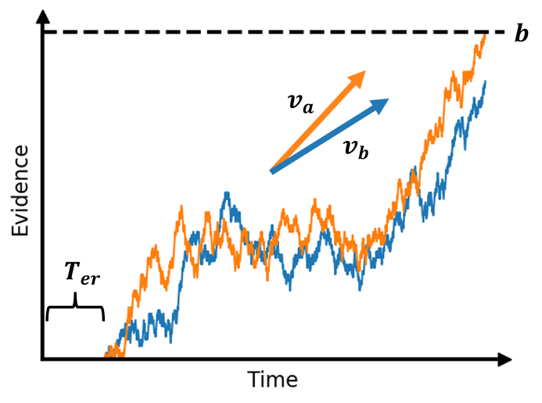
Figure 2. Racing Diffusion Model Schematic. Two competing accumulators race at average drift rates $v_{a}$ and $v_{b}$ until either reaches the evidence threshold $b$, at which point both processes terminate and the winning accumulator determines the chosen category. Time spent deliberating plus any non-decision time $T_{er}$ correspond with the choice’s response time.

RDMs offer a few major advantages over other more standard sequential sampling models for our analyses, such as classic drift diffusion models (DDMs) and linear ballistic accumulators (LBAs). First, separate accumulators will allow us to measure the magnitude of drift rate for each concept-attribute pair, unlike the relative difference that DDM’s single drift rate provides. This is important when modeling evidence accumulation for competing classes (e.g., Black/Bad or White/Good), as a single, relative drift rate between them could be indistinguishable between blocks while having very different drift magnitudes. For example, say a person accumulates evidence at rates of $v_{a}=2$ and $v_{b}=3$ on compatible blocks, and $v_{a}=0.5$ and $v_{b}=1.5$ on incompatible blocks. A single, relative drift rate would accumulate toward category b on both of these blocks ($v=-1$), but the difference in magnitude would be lost. A single accumulator would be blind to the average difference in evidence accumulation between blocks. Second, the RDM maintains that evidence accumulation is a noisy diffusion process, which better reflects how conflicting associations are theoretically activated than does the noiseless linear function assumed by LBAs. This noise also explains variability in response time, overcoming LBAs’ dependence on between-trial variability in starting point and drift rate. LBAs assume a constant, noiseless rate of evidence accumulation, so without between-trial variability they would predict identical, non-changing response times for every trial. Third, unlike the DDM and LBA, recent work suggests that assumptions of between-trial variability are not necessary for the RDM to model systematic variability in response time, and therefore the accumulator starting bias A can be dropped for a more parsimonious account³⁴. The inclusion of between-trial variability parameters in diffusion models has largely been motivated by the need to explain variation in response time, but those parameters don’t actually have a role in the process model itself and don’t serve good theory. The RDM better explains choices and response times without having to resort to theory-inconsistent parameters. Together, these advantages of RDMs combine the strengths of DDM and LBA to better model response caution and decision ease on IATs.
Evidence threshold, drift rates for each classification option, and non-decision time will be modeled hierarchically. We will leverage the full available dataset for each IAT to estimate group-level means and variances. These hyperparameters for evidence threshold, both drift rates, and non-decision time will be free to vary between IAT blocks. Hyperpriors will be weakly informative and constrained to be greater than 0, with the following distributions:
$$b_{μ}\sim N(0.5, 1)$$
$$b_{σ}\sim Γ(1, 1)$$
$$v_{a,μ}\sim N(2, 1)$$
$$v_{a,σ}\sim Γ(1, 1)$$
$$T_{μ}\sim N(0.5, 0.5)$$
$$T_{σ}\sim Γ(1, 1)$$
Although the group-level parameters will leverage the full dataset available for each IAT, subject-level parameters will only be estimated for participants who also completed an explicit preference thermometer for the IAT topic. Subject-level evidence thresholds, drift rates, and non-decision time will be free to vary with IAT block, and priors will be normally distributed with location and scale set to the block-specific group-level hyperparameter. Prior work suggests that non-decision time is related to neither method-specific nor construct-specific variance in IAT performance³⁰ and that non-decision time can be spuriously and negatively correlated with evidence thresholds, contributing to problems interpreting either parameter when both are free to vary⁵⁷. For these reasons, we also will test a model in which subject-level non-decision time was fixed across IAT blocks. Both models from our pilot analyses yield similar conclusions. Therefore, because the varying model may allow for a more comprehensive understanding of how IAT decisions are made, we will report analyses from the varying model here (see SI for simpler model with fixed non-decision time). All subject-level parameters will be constrained to be greater than 0. The likelihood of the response time data $t$ given the RDM parameters $b,v_{i},$ and $T_{er}$ will be calculated using separate Wald distributions⁵⁸ for each competing classification $i$. The Wald probability density function is:
$$p\left(t | b,v_{i},T_{er}\right)=\frac{b}{\sqrt{2π{(t-T_{er})}^{3}}}e^{\frac{-{(v_{i}(t-T_{er})-b)}^{2}}{2(t-T_{er})}}$$
RDMs will be separately fit to data from each of the IATs. An average 145,985.026 trials (SD=6,748.927) will be included from each of the 39 IATs for RDM model fitting, with an average 181.454 trials (SD=2.469) per participant for subject-level estimates. Prior work has found that both group-level and subject-level RDM parameters can be reliably recovered from far fewer trials and subjects³⁴. Posterior parameter distributions will be inferred using Hamiltonian Monte Carlo (HMC) No-U-Turn sampling in Stan⁵⁹. HMC is a Markov chain Monte Carlo sampling method for estimating the joint posterior of our RDM parameters. Four chains will be run in parallel at 2,000 iterations each. We will discard the first 1,000 iterations as warm-up samples. Chain convergence will be qualified with Gelman-Rubin diagnostics $\hat{R}$ less than or equal to 1.01⁶⁰.

Response Caution Score, Decision Ease Score, and Non-Decision Time Score. Following scoring methods for diffusion models used in prior IAT studies,³⁰ we will define “response caution score” as the difference in response caution between the incompatible and compatible blocks of each IAT. Similarly, we will define “decision ease score” as the difference in estimated decision ease between the incompatible and compatible blocks of each IAT. Last, we will define “non-decision time score” as the difference in estimated non-decision time between the incompatible and compatible blocks of each IAT.

Analysis Plan: Confirmatory Analyses
Pre-registered Hypothesis 1: Response Caution, Decision Ease, and Non-Decision Time differ between Mixed Blocks. To test whether response caution, decision ease, and non-decision time differ between the incompatible and compatible IAT blocks, we will conduct 39 Bayesian equivalence tests, three for each IAT dataset – one testing whether the response caution score is different from 0, another testing whether the decision ease score is different from 0, and the last testing whether the non-decision time score is different from 0. Scores will be derived from each IAT’s block-specific group-level evidence threshold, group-level average drift rate, and group-level non-decision time, respectively. We hypothesize that all three scores will differ between mixed blocks for any IAT. Comprehensive results from these individualized tests will be reported in SI and summary tests of aggregate effects across IATs will be reported in main text.
Bayesian equivalence tests determine whether a null value is among the credible values of the posterior distribution differences in response caution or decision ease. For each difference distribution we will establish a 95% highest density interval (HDI) representing the 95% most credible difference values. We will further establish a region of practical equivalence (ROPE) around the null difference value, specified as half of Cohen’s conventional effect sizes⁶¹, the range of -0.1 to 0.1 for small effects, -0.25 to 0.25 for moderate effects, and -0.4 to 0.4 for large effects, as suggested by Kruschke and Liddell⁶². In place of null-point Bayes factors, we will use Bayes factors vs. ROPE to test interval null hypotheses. Bayes factors vs. ROPE test for the odds of a posterior distribution falling within a region of practical equivalence to a null value, relative to the odds of a prior⁶³. For hypothesis testing, we will specify our posterior as the standardized difference distribution and our prior will be a standard Cauchy distribution. Using a Bayes factor vs ROPE decision rule, we will accept that a parameter difference is practically equivalent to the null value if there is 10x ROPE odds for the posterior over the prior (Bayes factor >= 10), and reject equivalence to the null value if there is 10x ROPE odds for the prior over the posterior (Bayes factor <= 0.1). All other cases (10 > Bayes factor > 0.1) will be considered weakly informative and left to interpretation.

Pre-registered Hypothesis 2: Response Caution explains significant variance in D-score and has a greater effect on D-score than does either Decision Ease, or Non-Decision Time. To test whether the three RDM scores predict IAT D-score, we will conduct 39 hierarchical OLS regression models, one for each IAT dataset. Decision ease scores and non-decision time scores will be entered first, then the response caution scores, in order to measure the unique contribution of response caution scores on the D-score. For this analysis, response caution, decision ease, and non-decision time scores will be derived from each IAT’s block-specific subject-level evidence threshold, subject-level average drift rate, and subject-level non-decision time, respectively. F-tests will be conducted between hierarchical regression blocks to determine whether there is a significant change in variance explained by including response caution score as a predictor. We hypothesize that response caution score will explain a significant proportion of variance in D-score above and beyond decision ease score and non-decision time score for each IAT. We further hypothesize that response caution score will have a significantly greater effect on D-score than will decision ease score or non-decision time score. We will repeat this analysis for each of the 6 D-score algorithms.

Pre-registered Hypothesis 3: Response Caution predicts Explicit Preference whereas Decision Ease and Non-Decision Time do not. To test whether response caution scores and decision ease scores predict IAT explicit preferences, we will conduct 39 OLS regression models, one for each IAT dataset, where decision ease score, response caution score, and non-decision time score will serve as predictors of explicit preference. For this analysis, response caution, decision ease, and non-decision time scores will be derived from each IAT’s block-specific subject-level evidence threshold, subject-level average drift rate, and subject-level non-decision time, respectively. We hypothesize that response caution score will predict explicit preference but neither decision ease score nor non-decision time score will not predict explicit preference.

Data Availability
We are committed to publicly sharing our raw data and materials. All data and materials will be uploaded to the Open Science Framework at https://osf.io/2r3zd/ upon acceptance of the Stage 2 manuscript.

Code Availability
We are committed to publicly sharing our code for analyses and model fitting. All code will be uploaded to the Open Science Framework at https://osf.io/2r3zd/ upon acceptance of the Stage 2 manuscript. All code will be thoroughly annotated to ease replication and seeds will be provided to replicate sampling.

References
1. Greenwald, A. G., & Banaji, M. R. (1995). Implicit social cognition: Attitudes, self-esteem, and stereotypes. Psychological Review, 102(1), 4–27. https://doi.org/10.1037/0033-295X.102.1.4
2. Greenwald, A. G., Brendl, M., Cai, H., Cvencek, D., Dovidio, J. F., Friese, M., Hahn, A., Hehman, E., Hofmann, W., Hughes, S., Hussey, I., Jordan, C., Kirby, T. A., Lai, C. K., Lang, J. W. B., Lindgren, K. P., Maison, D., Ostafin, B. D., Rae, J. R., … Wiers, R. W. (2022). Best research practices for using the Implicit Association Test. Behavior Research Methods, 54(3), 1161–1180. https://doi.org/10.3758/s13428-021-01624-3
3. Banaji, M. R., & Greenwald, A. G. (2016). Blindspot: Hidden biases of good people. Bantam Books.
4. Greenwald, A. G., McGhee, D. E., & Schwartz, J. L. K. (1998). Measuring individual differences in implicit cognition: The implicit association test. Journal of Personality and Social Psychology, 74(6), 1464–1480. https://doi.org/10.1037/0022-3514.74.6.1464
5. Nosek, B. A., Greenwald, A. G., & Banaji, M. R. (2007). The Implicit Association Test at age 7: A methodological and conceptual review. In Automatic processes in social thinking and behavior (Vol. 4, pp. 265–292). Psychology Press.
6. Prestwich, A., Kenworthy, J. B., Wilson, M., & Kwan-Tat, N. (2008). Differential relations between two types of contact and implicit and explicit racial attitudes. British Journal of Social Psychology, 47(4), 575–588. https://doi.org/10.1348/014466607X267470
7. Fazio, R. H., & Olson, M. A. (2003). Implicit Measures in Social Cognition Research: Their Meaning and Use. Annual Review of Psychology, 54(1), 297–327. https://doi.org/10.1146/annurev.psych.54.101601.145225
8. King, M. F., & Bruner, G. C. (2000). Social desirability bias: A neglected aspect of validity testing. Psychology and Marketing, 17(2), 79–103. https://doi.org/10.1002/(SICI)1520-6793(200002)17:2<79::AID-MAR2>3.0.CO;2-0
9. Gawronski, B., & Hahn, A. (2018). Implicit measures: Procedures, use, and interpretation. In Measurement in social psychology (pp. 29–55). Routledge.
10. De Houwer, J. (2006). Using the Implicit Association Test does not rule out an impact of conscious propositional knowledge on evaluative conditioning. Learning and Motivation, 37(2), 176–187. https://doi.org/10.1016/j.lmot.2005.12.002
11. Röhner, J., Schröder-Abé, M., & Schütz, A. (2011). Exaggeration is Harder Than Understatement, but Practice Makes Perfect!: Faking Success in the IAT. Experimental Psychology, 58(6), 464–472. https://doi.org/10.1027/1618-3169/a000114
12. Schindler, S., Wolff, W., Kissler, J. M., & Brand, R. (2015). Cerebral correlates of faking: Evidence from a brief implicit association test on doping attitudes. Frontiers in Behavioral Neuroscience, 9. https://doi.org/10.3389/fnbeh.2015.00139
13. De Houwer, J., Beckers, T., & Moors, A. (2007). Novel attitudes can be faked on the Implicit Association Test. Journal of Experimental Social Psychology, 43(6), 972–978. https://doi.org/10.1016/j.jesp.2006.10.007
14. Greenwald, A. G., Nosek, B. A., & Banaji, M. R. (2003). Understanding and using the implicit association test: I. An improved scoring algorithm. Journal of Personality and Social Psychology, 85(2), 197–216. https://doi.org/10.1037/0022-3514.85.2.197
15. Röhner, J., & Thoss, P. J. (2019). A tutorial on how to compute traditional IAT effects with {R}. The Quantitative Methods for Psychology, 15(2), 134–147. https://doi.org/10.20982/tqmp.15.2.p134
16. Hall, W. J., Chapman, M. V., Lee, K. M., Merino, Y. M., Thomas, T. W., Payne, B. K., Eng, E., Day, S. H., & Coyne-Beasley, T. (2015). Implicit Racial/Ethnic Bias Among Health Care Professionals and Its Influence on Health Care Outcomes: A Systematic Review. American Journal of Public Health, 105(12), e60–e76. https://doi.org/10.2105/AJPH.2015.302903
17. Chapman, E. N., Kaatz, A., & Carnes, M. (2013). Physicians and Implicit Bias: How Doctors May Unwittingly Perpetuate Health Care Disparities. Journal of General Internal Medicine, 28(11), 1504–1510. https://doi.org/10.1007/s11606-013-2441-1
18. Hehman, E., Flake, J. K., & Calanchini, J. (2018). Disproportionate Use of Lethal Force in Policing Is Associated With Regional Racial Biases of Residents. Social Psychological and Personality Science, 9(4), 393–401. https://doi.org/10.1177/1948550617711229
19. Van Den Bergh, L., Denessen, E., Hornstra, L., Voeten, M., & Holland, R. W. (2010). The Implicit Prejudiced Attitudes of Teachers: Relations to Teacher Expectations and the Ethnic Achievement Gap. American Educational Research Journal, 47(2), 497–527. https://doi.org/10.3102/0002831209353594
20. Chin, M. J., Quinn, D. M., Dhaliwal, T. K., & Lovison, V. S. (2020). Bias in the Air: A Nationwide Exploration of Teachers’ Implicit Racial Attitudes, Aggregate Bias, and Student Outcomes. Educational Researcher, 49(8), 566–578. https://doi.org/10.3102/0013189X20937240
21. Andersen, J. P., Di Nota, P. M., Boychuk, E. C., Schimmack, U., & Collins, P. I. (2023). Racial bias and lethal force errors among Canadian police officers. Canadian Journal of Behavioural Science / Revue Canadienne Des Sciences Du Comportement, 55(2), 130–141. https://doi.org/10.1037/cbs0000296
22. Payne, B. K., Vuletich, H. A., & Lundberg, K. B. (2017). The Bias of Crowds: How Implicit Bias Bridges Personal and Systemic Prejudice. Psychological Inquiry, 28(4), 233–248. https://doi.org/10.1080/1047840X.2017.1335568
23. Bar-Anan, Y., & Vianello, M. (2018). A multi-method multi-trait test of the dual-attitude perspective. Journal of Experimental Psychology: General, 147(8), 1264–1272. https://doi.org/10.1037/xge0000383
24. Falk, C. F., Heine, S. J., Takemura, K., Zhang, C. X. J., & Hsu, C.-W. (2015). Are Implicit Self-Esteem Measures Valid for Assessing Individual and Cultural Differences?: Implicit Self-Esteem. Journal of Personality, 83(1), 56–68. https://doi.org/10.1111/jopy.12082
25. Schimmack, U. (2021). The Implicit Association Test: A Method in Search of a Construct. Perspectives on Psychological Science, 16(2), 396–414. https://doi.org/10.1177/1745691619863798
26. Granados Samayoa, J. A., & Fazio, R. H. (2017). Who Starts the Wave? Let’s Not Forget the Role of the Individual. Psychological Inquiry, 28(4), 273–277. https://doi.org/10.1080/1047840X.2017.1373554
27. Schmitz, F., & Voss, A. (2012). Decomposing task-switching costs with the diffusion model. Journal of Experimental Psychology: Human Perception and Performance, 38(1), 222–250. https://doi.org/10.1037/a0026003
28. Röhner, J., & Thoss, P. (2018). EZ: An Easy Way to Conduct a More Fine-Grained Analysis of Faked and Nonfaked Implicit Association Test (IAT) Data. The Quantitative Methods for Psychology, 14(1), 17–37. https://doi.org/10.20982/tqmp.14.1.p017
29. Röhner, J., & Lai, C. K. (2021). A Diffusion Model Approach for Understanding the Impact of 17 Interventions on the Race Implicit Association Test. Personality and Social Psychology Bulletin, 47(9), 1374–1389. https://doi.org/10.1177/0146167220974489
30. Klauer, K. C., Voss, A., Schmitz, F., & Teige-Mocigemba, S. (2007). Process components of the Implicit Association Test: A diffusion-model analysis. Journal of Personality and Social Psychology, 93(3), 353–368. https://doi.org/10.1037/0022-3514.93.3.353
31. Haines, N., Kvam, P. D., Irving, L. H., Smith, C., Beauchaine, T. P., Pitt, M. A., Ahn, W.-Y., & Turner, B. (2020). Theoretically Informed Generative Models Can Advance the Psychological and Brain Sciences: Lessons from the Reliability Paradox [Preprint]. PsyArXiv. https://doi.org/10.31234/osf.io/xr7y3
32. Kvam, P. D., Irving, L. H., Sokratous, K., & Smith, C. (2022). Improving the reliability and validity of the IAT with a dynamic model driven by similarity [Preprint]. PsyArXiv. https://doi.org/10.31234/osf.io/ke7cp
33. Elder, J., Wilson, L., & Calanchini, J. (2023). Estimating the Reliability and Stability of Cognitive Processes Contributing to Responses on the Implicit Association Test. Personality and Social Psychology Bulletin, 014616722311712. https://doi.org/10.1177/01461672231171256
34. Tillman, G., Van Zandt, T., & Logan, G. D. (2020). Sequential sampling models without random between-trial variability: The racing diffusion model of speeded decision making. Psychonomic Bulletin & Review, 27(5), 911–936. https://doi.org/10.3758/s13423-020-01719-6
35. Ratcliff, R. (1978). A theory of memory retrieval. Psychological Review, 85(2), 59–108. https://doi.org/10.1037/0033-295X.85.2.59
36. Ratcliff, R., Smith, P. L., Brown, S. D., & McKoon, G. (2016). Diffusion Decision Model: Current Issues and History. Trends in Cognitive Sciences, 20(4), 260–281. https://doi.org/10.1016/j.tics.2016.01.007
37. Brendl, C. M., Markman, A. B., & Messner, C. (2001). How do indirect measures of evaluation work? Evaluating the inference of prejudice in the Implicit Association Test. Journal of Personality and Social Psychology, 81(5), 760–773. https://doi.org/10.1037/0022-3514.81.5.760
38. Röhner, J., & Ewers, T. (2016). Trying to separate the wheat from the chaff: Construct- and faking-related variance on the Implicit Association Test (IAT). Behavior Research Methods, 48(1), 243–258. https://doi.org/10.3758/s13428-015-0568-1
39. Wagenmakers, E.-J. (2009). Methodological and empirical developments for the Ratcliff diffusion model of response times and accuracy. European Journal of Cognitive Psychology, 21(5), 641–671. https://doi.org/10.1080/09541440802205067
40. Shevlin, B. R. K., Smith, S. M., Hausfeld, J., & Krajbich, I. (2022). High-value decisions are fast and accurate, inconsistent with diminishing value sensitivity. Proceedings of the National Academy of Sciences, 119(6), e2101508119. https://doi.org/10.1073/pnas.2101508119
41. Pleskac, T. J., Cesario, J., & Johnson, D. J. (2018). How race affects evidence accumulation during the decision to shoot. Psychonomic Bulletin & Review, 25(4), 1301–1330. https://doi.org/10.3758/s13423-017-1369-6
42. Forstmann, B. U., Ratcliff, R., & Wagenmakers, E.-J. (2016). Sequential Sampling Models in Cognitive Neuroscience: Advantages, Applications, and Extensions. Annual Review of Psychology, 67(1), 641–666. https://doi.org/10.1146/annurev-psych-122414-033645
43. Barbosa, L. S., Vlassova, A., & Kouider, S. (2017). Prior expectations modulate unconscious evidence accumulation. Consciousness and Cognition, 51, 236–242. https://doi.org/10.1016/j.concog.2017.04.001
44. Vlassova, A., Donkin, C., & Pearson, J. (2014). Unconscious information changes decision accuracy but not confidence. Proceedings of the National Academy of Sciences, 111(45), 16214–16218. https://doi.org/10.1073/pnas.1403619111
45. Ratcliff, R., & Rouder, J. N. (2000). A diffusion model account of masking in two-choice letter identification. Journal of Experimental Psychology: Human Perception and Performance, 26(1), 127–140. https://doi.org/10.1037/0096-1523.26.1.127
46. Katsimpokis, D., Hawkins, G. E., & Van Maanen, L. (2020). Not all Speed-Accuracy Trade-Off Manipulations Have the Same Psychological Effect. Computational Brain & Behavior, 3(3), 252–268. https://doi.org/10.1007/s42113-020-00074-y
47. Milosavljevic, M., Malmaud, J., Huth, A., Koch, C., & Rangel, A. (2010). The Drift Diffusion Model can account for the accuracy and reaction time of value-based choices under high and low time pressure. Judgment and Decision Making, 5(6), 437–449. https://doi.org/10.1017/S1930297500001285
48. Voss, A., Rothermund, K., & Voss, J. (2004). Interpreting the parameters of the diffusion model: An empirical validation. Memory & Cognition, 32(7), 1206–1220. https://doi.org/10.3758/BF03196893
49. Matzke, D., & Wagenmakers, E.-J. (2009). Psychological interpretation of the ex-Gaussian and shifted Wald parameters: A diffusion model analysis. Psychonomic Bulletin & Review, 16(5), 798–817. https://doi.org/10.3758/PBR.16.5.798
50. Cavanagh, J. F., Wiecki, T. V., Cohen, M. X., Figueroa, C. M., Samanta, J., Sherman, S. J., & Frank, M. J. (2011). Subthalamic nucleus stimulation reverses mediofrontal influence over decision threshold. Nature Neuroscience, 14(11), 1462–1467. https://doi.org/10.1038/nn.2925
51. Frank, M. J., Gagne, C., Nyhus, E., Masters, S., Wiecki, T. V., Cavanagh, J. F., & Badre, D. (2015). FMRI and EEG Predictors of Dynamic Decision Parameters during Human Reinforcement Learning. The Journal of Neuroscience, 35(2), 485–494. https://doi.org/10.1523/JNEUROSCI.2036-14.2015
52. Van Maanen, L., Brown, S. D., Eichele, T., Wagenmakers, E.-J., Ho, T., Serences, J., & Forstmann, B. U. (2011). Neural Correlates of Trial-to-Trial Fluctuations in Response Caution. The Journal of Neuroscience, 31(48), 17488–17495. https://doi.org/10.1523/JNEUROSCI.2924-11.2011
53. Forstmann, B. U., Dutilh, G., Brown, S., Neumann, J., Von Cramon, D. Y., Ridderinkhof, K. R., & Wagenmakers, E.-J. (2008). Striatum and pre-SMA facilitate decision-making under time pressure. Proceedings of the National Academy of Sciences, 105(45), 17538–17542. https://doi.org/10.1073/pnas.0805903105
54. Schmidt, K., Stevens, A., Szabelska, A., Graham, J., Hawkins, C. B., & Nosek, B. A. (2022). The Ideology 2.0 Dataset. https://osf.io/2483h/
55. Krajbich, I. (2022). Decomposing Implicit Bias. Psychological Inquiry, 33(3), 181–184. https://doi.org/10.1080/1047840X.2022.2106758
56. Voss, A., Nagler, M., & Lerche, V. (2013). Diffusion Models in Experimental Psychology: A Practical Introduction. Experimental Psychology, 60(6), 385–402. https://doi.org/10.1027/1618-3169/a000218
57. Grange, J. A., & Schuch, S. (2022). A spurious correlation between difference scores in evidence-accumulation model parameters. Behavior Research Methods. https://doi.org/10.3758/s13428-022-01956-8
58. Wald, A. (1947). Sequential analysis. Wiley.
59. Carpenter, B., Gelman, A., Hoffman, M. D., Lee, D., Goodrich, B., Betancourt, M., Brubaker, M., Guo, J., Li, P., & Riddell, A. (2017). Stan: A Probabilistic Programming Language. Journal of Statistical Software, 76(1). https://doi.org/10.18637/jss.v076.i01
60. Gelman, A., & Rubin, D. B. (1992). Inference from Iterative Simulation Using Multiple Sequences. Statistical Science, 7(4). https://doi.org/10.1214/ss/1177011136
61. Cohen, J. (1988). Statistical Power Analysis for the Behavioral Sciences. Routledge Academic.
62. Kruschke, J. K., & Liddell, T. M. (2018). The Bayesian New Statistics: Hypothesis testing, estimation, meta-analysis, and power analysis from a Bayesian perspective. Psychonomic Bulletin & Review, 25(1), 178–206. https://doi.org/10.3758/s13423-016-1221-4
63. Morey, R. D., & Rouder, J. N. (2011). Bayes factor approaches for testing interval null hypotheses. Psychological Methods, 16(4), 406–419. https://doi.org/10.1037/a0024377

Author Contributions
The authors confirm contribution to the paper as follows: Study conception and design: K. J. LaFollette, D. Rubez, H. A. Demaree, & A. Goldenberg; Analysis and Interpretation of Results: K. J. LaFollette; Draft Manuscript Preparation: K. J. LaFollette, D. Rubez, H. A. Demaree, & A. Goldenberg. All authors reviewed the results and approve of the final version of the manuscript.

Competing Interests
The authors declare no competing interests.

Design Table
Question | Hypothesis | Sampling plan (e.g. power analysis) | Analysis Plan | Interpretation given to different outcomes
Does decision ease (i.e., rate of evidence accumulation) and response caution (i.e., evidence threshold) and non-decision time differ between compatible and incompatible blocks? | All three processes - response caution, decision ease, and non-decision time - will differ between mixed blocks for any IAT. | Our pilot analyses revealed strong evidence for effects of decision ease, response caution, and non-decision time between blocks (all BF>10 for at least moderate effects). Our exploratory analyses at the pilot stage consisted of 34,743 participants. We expect to have 109,417 participants in the final confirmatory sample and a minimum of 2,496 participants for any IAT. | We will conduct three Bayesian equivalence tests for each of the 39 IATs - each one testing whether the difference in response caution, decision ease, or non-decision time is different from a region of practical equivalence to 0 ([-0.1, 0.1] for small effects, [-0.25, 0.25] for moderate effects, and [-0.4, 0.4] for large effects). | A positive difference in response bias between the two blocks indicates that the person is more cautious in the incompatible block. A negative difference between the blocks for the decision ease parameter indicates a stronger association between target-attribute pairs on the compatible block than the incompatible block. A negative difference between the blocks for non-decision time indicates faster non-decision processes in the incompatible than compatible block.
Does response caution explain significant variance in D-score, above and beyond the decision ease and non-decision time scores? | (1) Response caution score will have a greater effect on D-score than either decision ease or non-decision time scores. (2) Response caution score will explain significant variance in D-score, above and beyond that explained by either decision ease or non-decision time scores. | The minimum sample size for any particular IAT is N = 1,327. Pilot analyses suggest large effect sizes. A power analysis with large effect size and power 0.95 suggests that N = 238 per each IAT is sufficient for the analyses. | We will conduct 39 hierarchical regression models, one for each IAT dataset, where decision ease and non-decision time scores will serve as the first two predictors in block 1, response caution will be added as a predictor in block 2, and D-score will serve as the outcome measure. F-change will test (1), and standardized betas in block 2 will test (2). We will repeat this for all 6 D-score algorithms | If response caution score explains a significant portion of the variance in the D-score that will suggest that the D-score is confounded by processes unrelated to the activation of associative memory content, as is assumed in the standard definition of implicit bias.
Does response caution, decision ease, and non-decision time on IAT predict explicit preference for that IAT’s topic? | Response caution score will predict explicit preference but neither decision ease score nor non-decision time score will not predict explicit preference. | The minimum sample size for any particular IAT is N = 1,327. Pilot analyses suggest small effect sizes. A power analysis with small effect size and power 0.95 suggests that N = 238 per each IAT is sufficient for the analyses. | We will conduct 39 OLS regression models, one for each IAT dataset, where decision ease score, response caution score, and non-decision time score will serve as predictors of explicit preference. | If response caution score predicts explicit preference but decision ease score does not, that will suggest that explicit preference more so reflects response caution than it does processes traditionally assumed to reflect implicit bias.

